Nama : Revan Febriansyah

NIM :18090091

Kelas : 5D

**PRAKTIKUM 3**

1. Source Code

Matakuliah.php-> application/controller

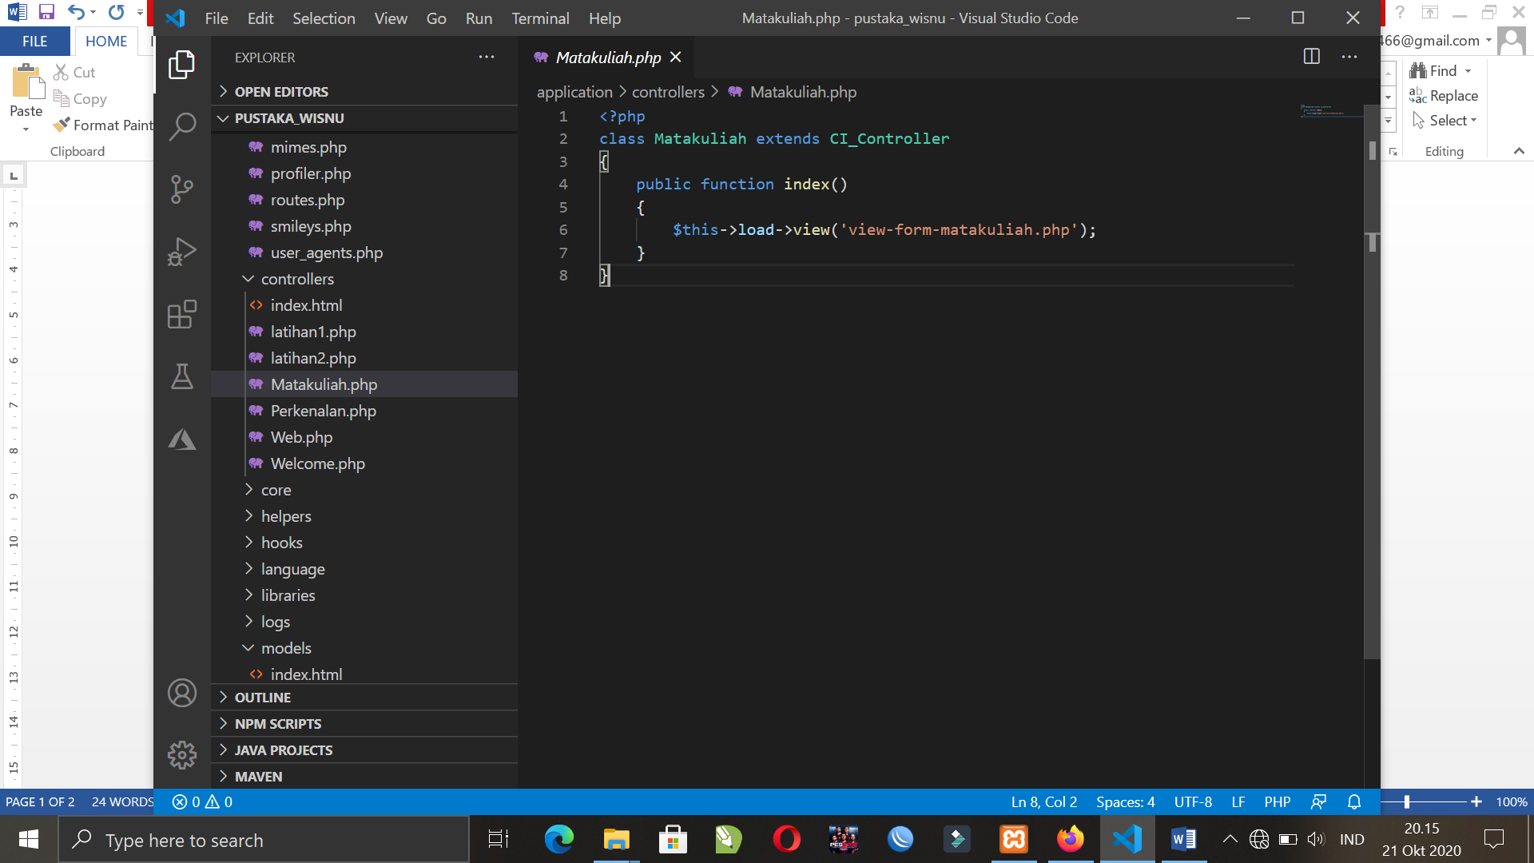

View-form-matakuliah.php->application/view

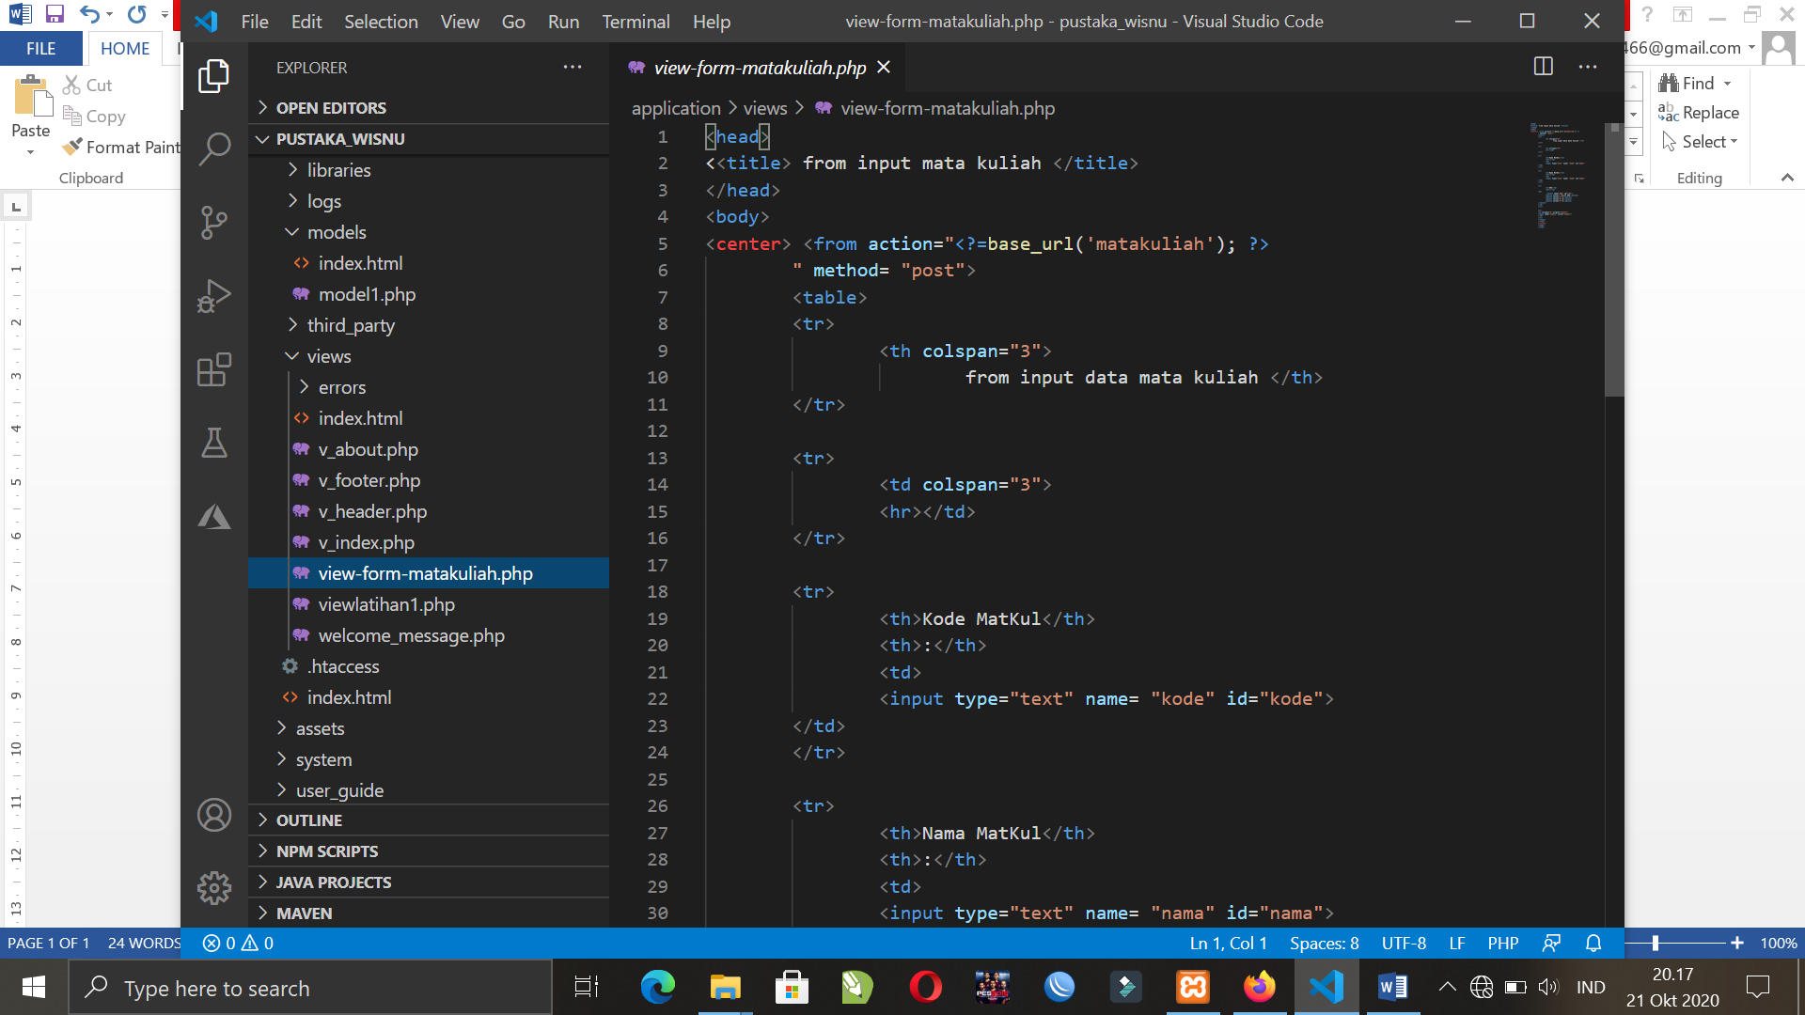

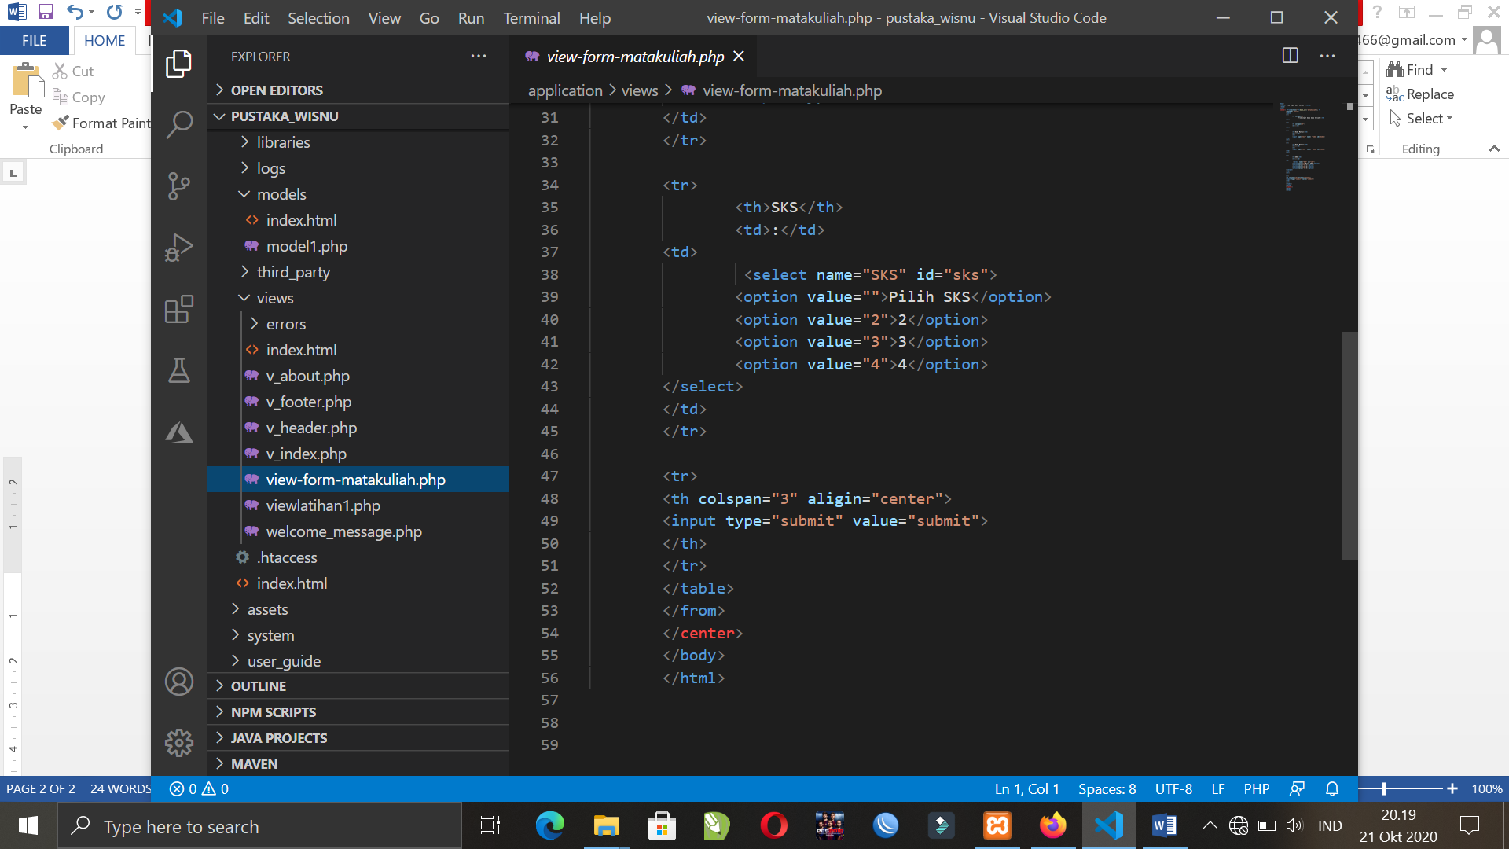

1. URL

<http://localhost/pustaka_revan/index.php/Matakuliah>

1. Capture Hasil

